# Exercises: Implement Trees and Traversals

This document defines the **in-class exercises** assignments for the ["Data Structures" course @ Software University](https://softuni.bg/trainings/1147/Data-Structures-June-2015). You have to **implement a tree** and **traverse it** recursively.

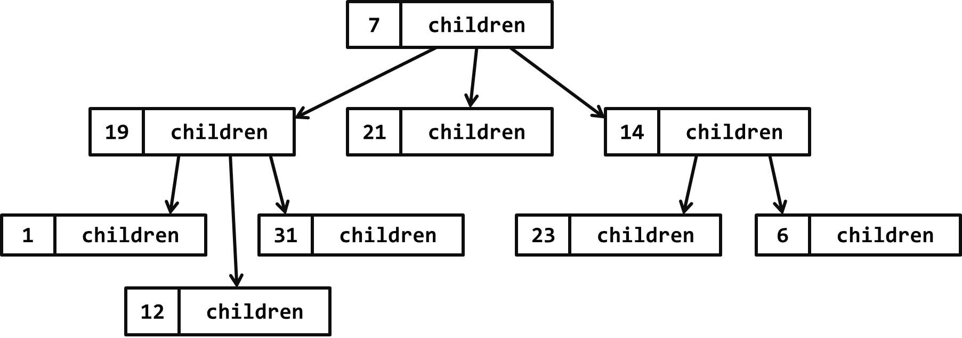

In the figure above, the **tree nodes** hold a **value** and a **list of descendent tree nodes**. It is recursive data structure.

# Part I – Implement a Tree

The first part of this lab aims to implement a **tree** (a node that holds a value and multiple child nodes).

## Trees – Project Skeleton

You are given a **Visual Studio project skeleton** (unfinished project) holding the unfinished Tree<T> and BnaryTree<T> classes and **unit tests** for their functionality. The project holds the following assets:

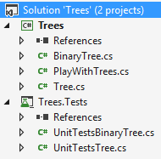

The project skeleton opens correctly in **Visual Studio 2013** but can be open in other Visual Studio versions as well and also can run in **SharpDevelop** and **Xamarin Studio**.

The unfinished Tree<T> class stays in the file Tree.cs:

|  |
| --- |
| Tree.cs |
| public class Tree<T>  {  public Tree(T value, params Tree<T>[] children) { … }  public void Print(int indent = 0) { … }  public void Each(Action<T> action) { … }  } |

The unfinished BinaryTree<T> class stays in the file BinaryTree.cs:

|  |
| --- |
| BinaryTree.cs |
| public class BinaryTree<T>  {  public BinaryTree(T value, BinaryTree<T> leftChild = null,  BinaryTree<T> rightChild = null) { … }  public void PrintIndentedPreOrder(int indent = 0) { … }  public void EachInOrder(Action<T> action) { … }  public void EachPostOrder(Action<T> action) { … }  } |

The project comes with **unit tests** covering the entire functionality of the trees (see the files UnitTestsTree.cs and UnitTestsBinaryTree.cs):

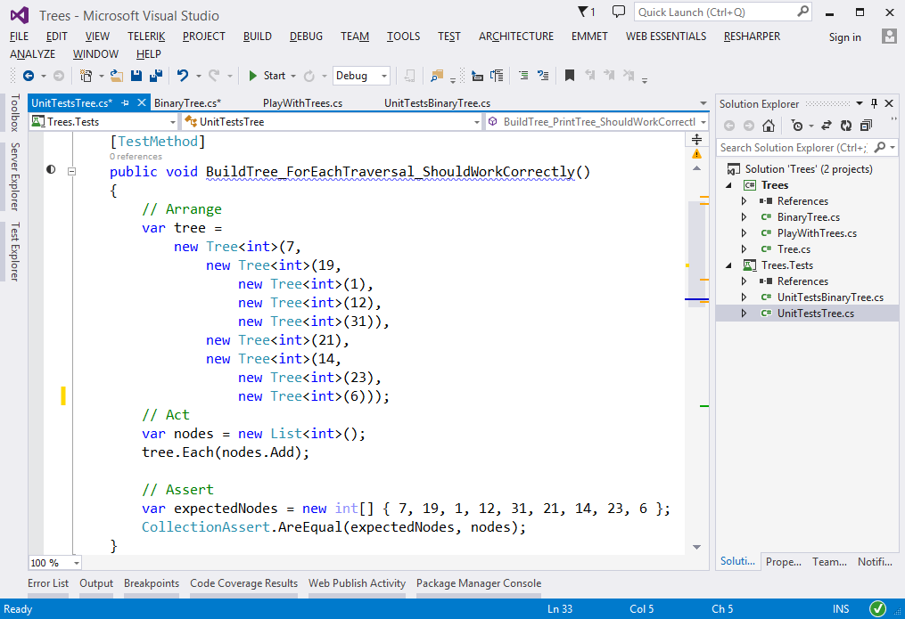

## Run the Unit Tests to Ensure All of Them Initially Fail

**Run the unit tests** from the Trees.Tests project. Open the "**Test Explorer**" window (Menu 🡪 Test 🡪 Windows 🡪 Test Explorer) and run all tests. The expected behavior is that all tests should fail:

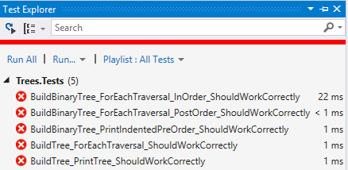

This is quite normal. We have unit tests, but the code covered by these tests is missing. Let's write it.

## Define the Tree<T> Data Structure

The first step is to define the inner **data** hold **tree nodes**. It should hold the node **value** and a list of **child nodes**:

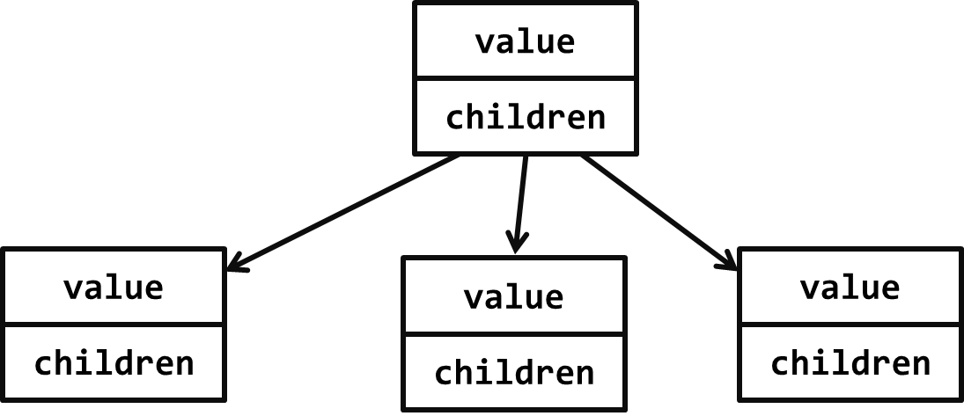

The source code might look like this:

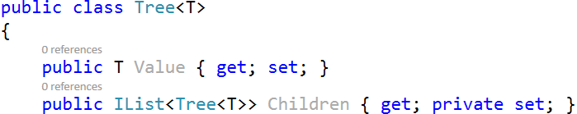

## Define the Tree<T> Constructor

The next step is to define a **constructor** for the Tree<T> class to ensure you can create:

* **Leaf tree nodes** (holding a specified value) without child nodes, e.g.  
  
* **Internal tree nodes** (holding a specified value) with child nodes, e.g.  
  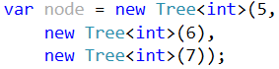

You can use **optional parameters** for the child nodes to combine the above two constructors. A sample source code is shown below:

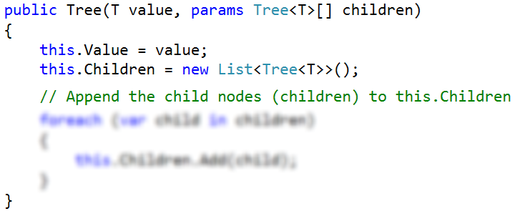

The parameter children is optional, so it could be passed or skipped. The goal is to allow creating trees by invoking **nested constructors** like these:

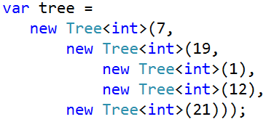

## Test the Tree<T> Constructor

Now, test whether the Tree<T> and its constructor work as expected.

1. Use the debugger to set a breakpoint in the file PlayWithTrees.cs just after the tree construction.
2. Use the [Locals] debug window to browse the tree structure and the **child nodes** for each tree node.

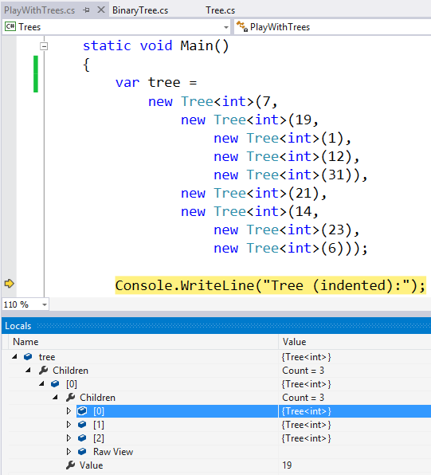

## Define the Print() Method

Now, we need to implement the **tree functionality**. First, implement the Print() method. It works recursively:

* Prints the current node value (indented a few spaces on the right).
* Calls the Print() method recursively to **print all child nodes** of the current node.

The code might look like this:

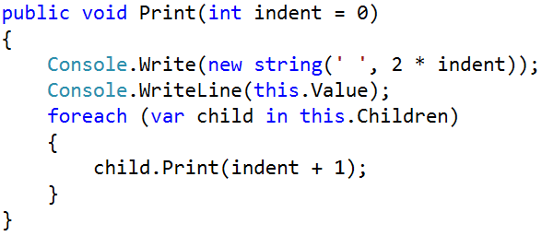

## Test the Print() Method

To test the Print() method, **run the unit tests**. Some of them should pass successfully:

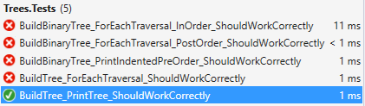

## Implement "For Each" Traversal

Now, implement the Each(Action<T>) method that **traverses the tree** recursively from its root to its leaves and invokes the provided **action function** for each visited tree node. It works as follows:

* Process the current node value (invokes the action function on it).
* Calls the Each() method recursively to **process all child nodes** of the current node.

The source code might look as follows:

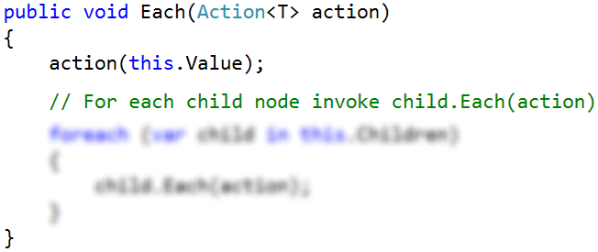

## Test the Each(Action<T>) Method

To test the Each(Action<T>) method, **run the unit tests**. All tests now should pass successfully:

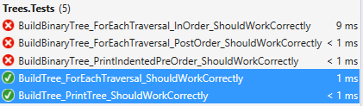

The failed tests cover the BinaryTree<T> class, which is still not implemented.

Congratulations! You have implemented your tree data structure.

# Part II – Implement a Binary Tree

The second part of this lab aims to implement a **binary tree** (a node that holds a value + left and right child nodes).

## Define the BinaryTree<T> Data Structure

The first step is to define the inner **data** hold **binary** **tree nodes**. It should hold the node **value** + **left** and **right** **child nodes** (both of them are optional and can be null):

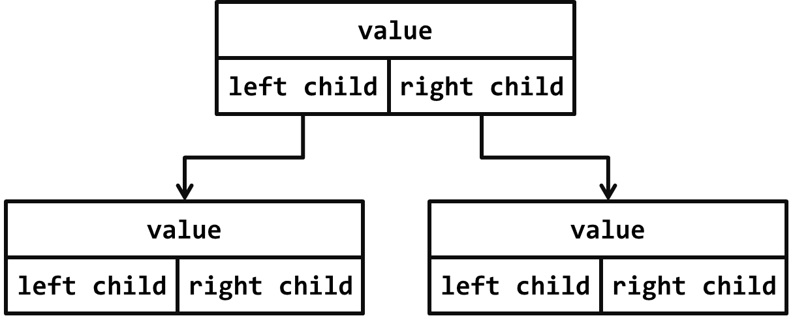

The source code might look like this:

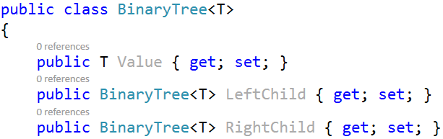

## Define the BinaryTree<T> Constructor

The next step is to define a **constructor** for the BinaryTree<T> class to ensure you can create:

* **Leaf tree nodes** (holding a specified value) without child nodes, e.g.  
  
* **Internal tree nodes** (holding a specified value) with left and right child nodes, e.g.  
  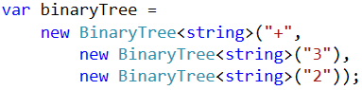

You can use **optional parameters** (holding null by default) for the child nodes to combine the above two constructors. A sample source code is shown below:

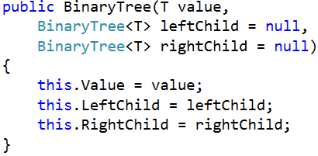

The parameters leftChild and rightChild are optional and can be passed or skipped. This will allow constructing binary tree like this:

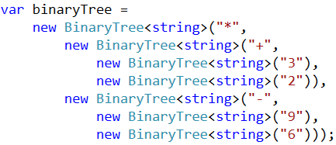

## Test the BinaryTree<T> Constructor

Now, test whether the BinaryTree<T> and its constructor work as expected.

1. Use the debugger to set a breakpoint in the file PlayWithTrees.cs just after the binary tree construction.
2. Use the [Locals] debug window to browse the binary tree structure and the **child nodes** for each tree node (left and right child).

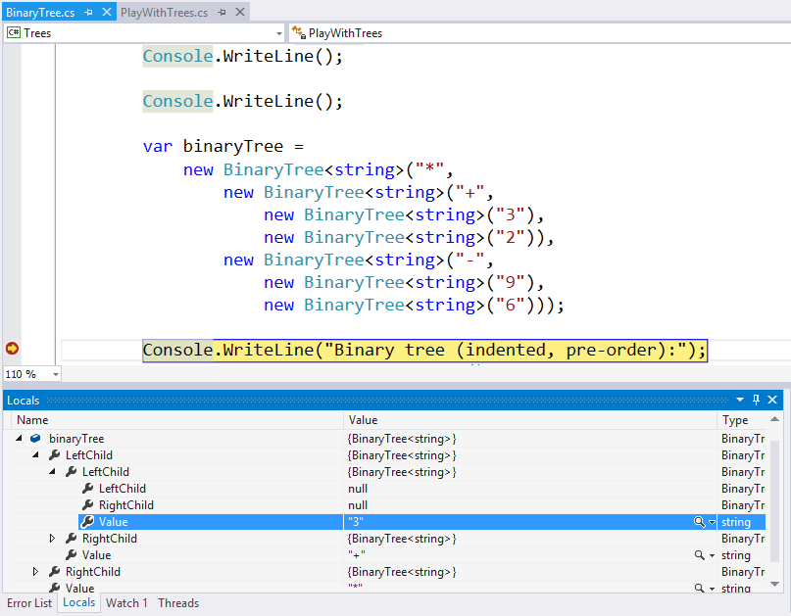

## Define the PrintIndentedPreOrder() Method

Now, we need to implement the **binary** **tree functionality**. First, implement the PrintIndentedPreOrder() method. It prints the tree in pre-order (root; left; right), indented visually like this:

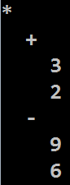

The PrintIndentedPreOrder() method works recursively:

* Prints the current node value (indented a few spaces on the right).
* Calls the PrintIndentedPreOrder() method recursively to **print the left child** of the current node (when exists).
* Calls the PrintIndentedPreOrder() method recursively to **print the right child** of the current node (when exists).

The code might look like this:

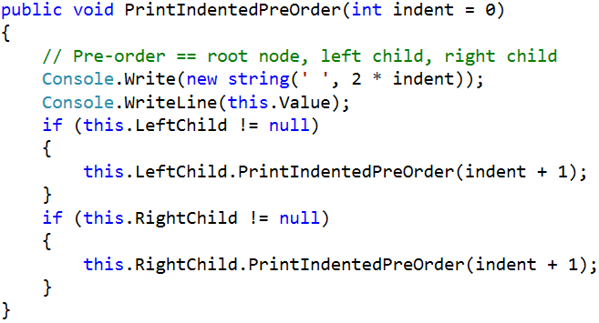

## Test the PrintIndentedPreOrder() Method

To test the PrintIndentedPreOrder() method, **run the unit tests**. Some of them should pass successfully:

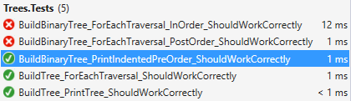

## Implement the EachInOrder(Action<T>) Method

Next, let's implement the EachInOrder(Action<T>) method that traverses the binary tree in **in-order** (left; root; right). It is again recursive, very similar to the previous method:

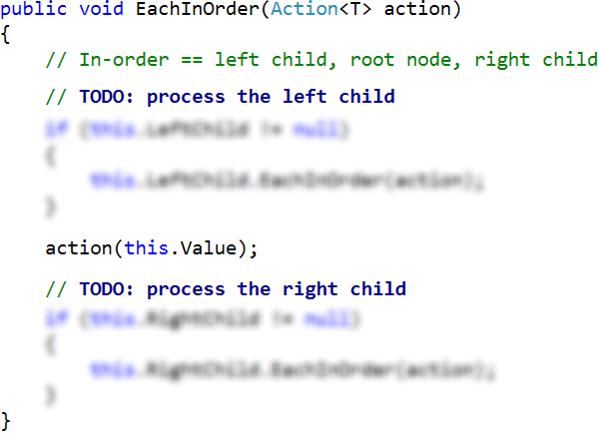

## Test the EachInOrder(Action<T>) Method

To test the EachInOrder(Action<T>) method, **run the unit tests**. One more test now should pass successfully:

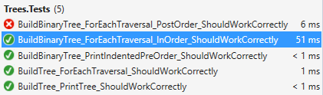

## Implement the EachPostOrder(Action<T>) Method

Next, let's implement the EachPostOrder(Action<T>) method that traverses the binary tree in **post-order** (left; right; root). It is again recursive, very, very similar to the previous method:

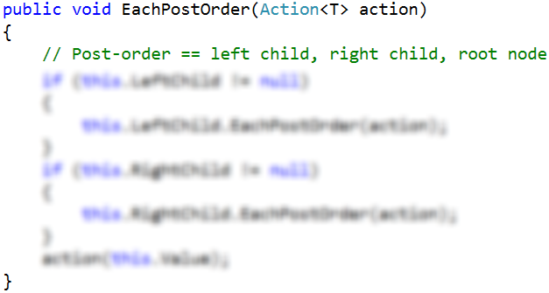

## Test the EachPostOrder(Action<T>) Method

To test the EachPostOrder(Action<T>) method, **run the unit tests**. All tests should now pass successfully:

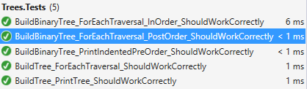

Congratulations! You have implemented your binary tree data structure.